Axess Urogynaecology Service

Ring Pessary for pelvic organ prolapse (vaginal prolapse)
Information for women
What is pelvic organ prolapse?
Pelvic organ prolapse is a very common condition where the walls of the vagina and uterus (womb) are no longer supported. They bulge down within and sometimes outside the vagina.
What causes a prolapse?
- Pregnancy and childbirth
- Getting older
- Being overweight
- Chronic constipation and straining
- Persistent coughing
What are the symptoms of prolapse?
- The feeling of a lump “coming down”
- Heaviness or a dragging sensation inside your vagina
- Backache
- Not being able to empty your bowel or bladder fully
These symptoms tend to be worse if you have been standing for a long time or at the end of the day. The symptoms often improve on lying down.
How is prolapse treated?
- Lifestyle changes: such as losing weight and stopping smoking
- Pelvic floor exercises may help strengthen your pelvic floor muscles. You can discuss referral to a physiotherapist with your GP
- Vaginal ring pessary may be suitable: If you wish to avoid surgery, are not fit for surgery, want to control symptoms whilst waiting for surgery or if you are planning on having further children
- Surgery
What is a vaginal ring pessary?
A ring pessary is round in shape and comes in many different sizes. It is inserted into the vagina to hold a prolapsed uterus (womb) and/or vaginal walls in place.
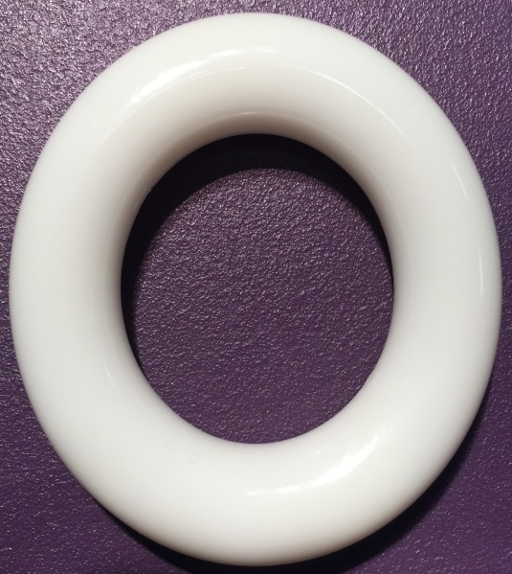

What are the benefits?
Although it does not cure your prolapse, it will help to ease symptoms and make you feel more comfortable. Once it is in place you should not be able to feel it.
What are the risks?
There are few side effects and risks.
Some women may experience the following
- Slight watery discharge
- Vaginal discharge
- Vaginal irritation
- Difficulty passing urine
- Pessary falling out
- Bleeding from the vagina. This may be caused by the pessary causing ulcers (sores) inside the vagina. This is reduced by having the pessary changed every six months.
How is a ring pessary fitted?
A vaginal examination will be carried out by a specialist nurse or doctor, which gives an estimate of the size of pessary needed. It may take more than one fitting to find the correct size for you.
After fitting you will be asked to walk around and go to the toilet to ensure that it is comfortable and you can pass urine. You should not be able to feel it. Once you feel comfortable with the pessary you can go home and carry on daily activities.
If it is uncomfortable or you cannot pass urine you may need a different size.
How often should my ring pessary be changed?
Every 6 months you will receive an appointment to come back to clinic. The pessary will be removed. You will be checked for any problems such as bleeding before a new one is inserted.
How long can I continue using a ring pessary?
There is no time limit for how long you can use one as long as it is helping with your symptoms and you have it changed every six months.
Am I able to have sex with a pessary inside?
If you are in a sexual relationship and want to continue having sex there is no reason why you cannot if it feels comfortable for you both.
What should I do if I have any problems with my ring pessary?
If you have any problems or concerns with your ring pessary please phone your GP.

